ST FRANCIS BAY BRIDGE CLUB

Minutes of the committee meeting held on
Thursday 01 October 2015 at the Heritage Centre at 12h00

- Geoff welcomed the committee members and mentioned that it was a pleasant change to have the entire committee present!

- The minutes of the previous meeting held on 20 August were confirmed by all present.

- Matters arising

  - The costs of running a Standard Bank Cheque account for the duration of the 2016 Annual Tournament will be investigated by ROGER.
  - The donation to Hospice of R4300 (profit from the 2015 Annual Tournament) has been handed over by Geoff to Malcom Devine. A photo and article were published in the local “St Francis Today”.

- Annual Tournament 2016
  - The date of 13-15 May 2016 was confirmed. GEOFF will inform Heidi and JUDY will confirm with Eugenie at the Links.
  - Early bookings will be handled as follows
    - 8 slots will be reserved for 8 teams of club members.
    - Roger will draw up a list of those visitors that have already indicated their intention to attend. They will be contacted before the booking opens and asked to indicate whether or not they still wish to attend. Those that reply in the affirmative will have their names entered on the booking list.
    - Bookings will officially open next year by email on a date still to be determined. This information will be contained in the flyer that will be sent out before the date of the official opening of the bookings.
    - The first 28 teams on the booking list will be asked to pay by a certain date after which the names of those that have not paid will be removed and their positions offered to the next on the list. Confirmation of payment must be sent to Roger on email.
    - Cost will be R600 per head for visitors and R550 per head for members.
    - Any profit will go to the club for new equipment.

- Charity Day 2015 report back

[22 tables – 2 sections of 11 tables in each – 44 boards played in each section – 4 per round. 2 sets of identical boards supplied and dealt by Heidi. Eileen Ellis and Judith O’Hara were the TDs.
Tickets R150 each. This included a finger lunch and tea for which the Links charged R85.Eileen provided shortbread and 3 ladies brought sandwiches, for tea]

  - John, who was the MC, reported that it all went smoothly. The Links team headed by Eugenie was extremely helpful at all times. However the food was below expectation and in particular the wraps were not good. The mix of savoury and sweet offerings on the same table was confusing. JOHN will write to Eugenie and let her know of our disappointment in this regard.
  - Wendy has written all the thank you letters to those that donated prizes. See addendum A.
  - ROGER is working on correlating pair numbers in the results for the entire entry, to those of the individual sections. This is not done by the scoring program but can be explained to the players in a file that will be created and added to the web.
  - Roger mentioned that the paper travellers used were a waste of time. The Bridgemates (version II) contain this information rendering paper travellers redundant.
  - Theonie submitted the financial report. A profit of R6300 has been made.
  - The profit will be officially handed over to the NSRI on Monday 05 October during the tea break.

- Bridgemates – these now cost R1900 each. We have 22. It was decided not to buy any more at this stage. These are kept in the new suitcase by Geoff.

- Storage – report from Geoff (received on email prior to the meeting) – see addendum B.

Insurance – THEONIE was asked to enquire about increasing the insurance on our existing and new equipment.

- TD Course – to be held on Tuesday 20th October in the Heritage Centre. Delivery by Eileen assisted by Judith. GEOFF will ensure that the invites are sent out.

- Arrangements for the Christmas Bridge Morning on Friday 04 December were deferred until the end of October except for the menu portfolio which was assigned to JOHN.

- General – Geoff reported that he will be away 7-28th October and Cookie will be away 3rd-11th October.

The meeting adjourned at 13h30.

Addendum A
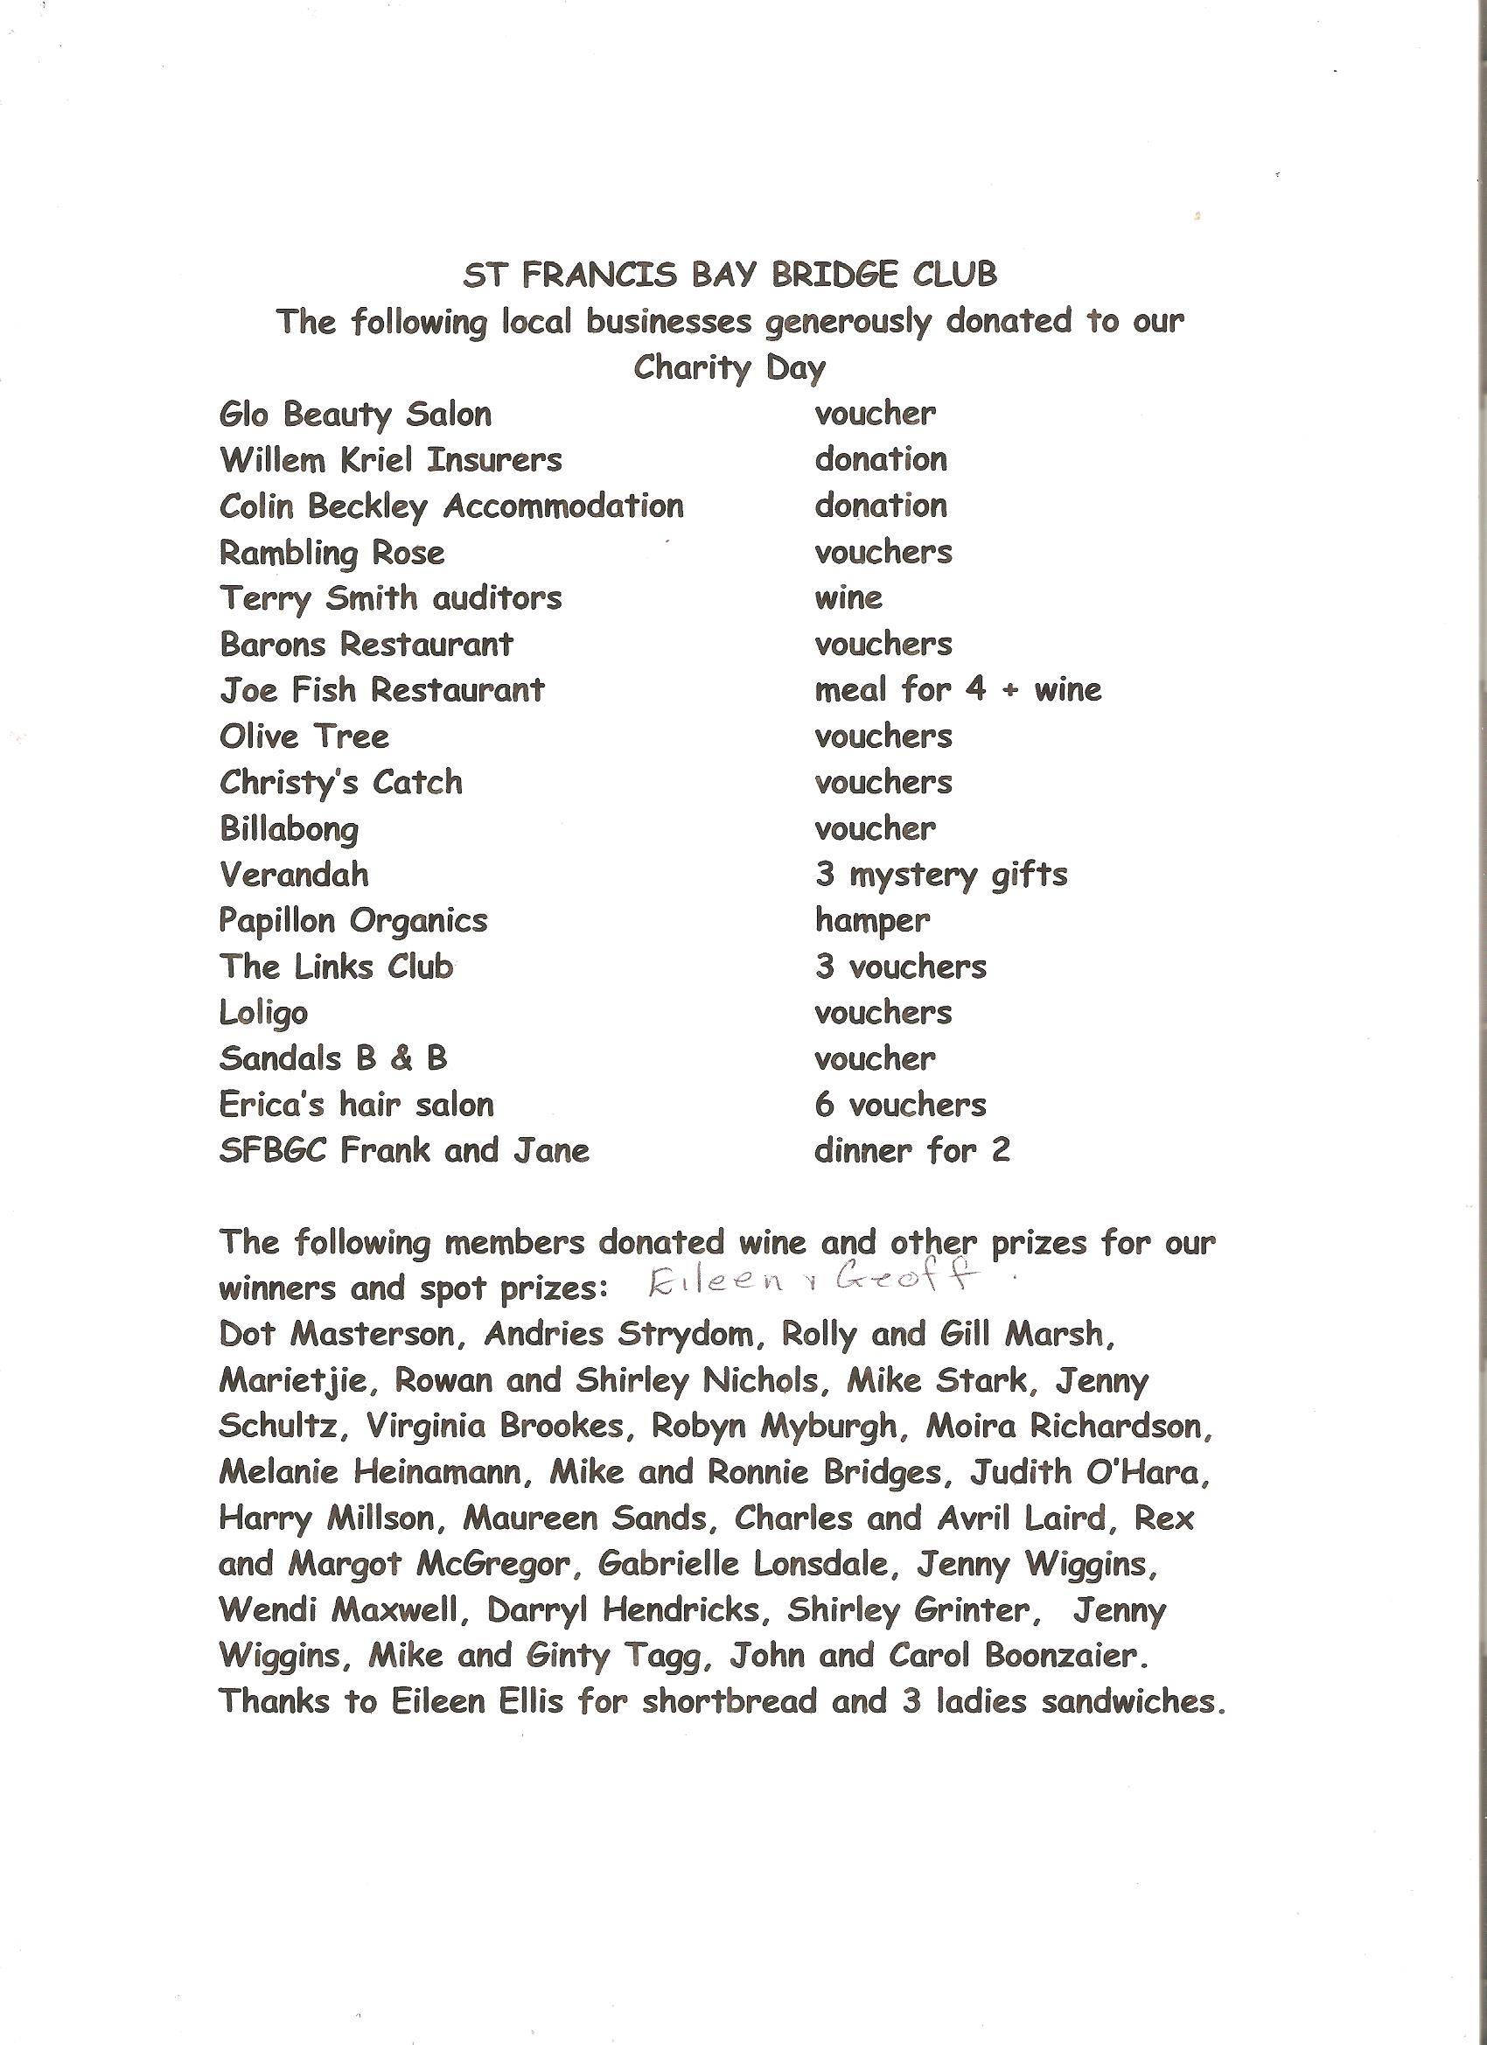

Addendum B

We have 9 sets of boards in suitcases, 3 sets each of
- 28 HC Thursday,
- 32 Links Monday, and
- 36 Links Friday.
1 of each in use, and the other 2 to be stored. Plus one with spare cards.

All of this can fit in the HC, so we have now:
- The bidding boxes and Thursday boards in the white cupboard. This has a lock with our code in.
- 6 cases in the cupboard that had the boxes/boards.
- 2 cases in the Bridgemate cupboard.
- TD book and course material in the same cupboard.
- Stock of tea, coffee and snacks in the crockery cupboard.
- A box of extras should fit in the white cupboard.
Let’s see how it works before we build another cupboard.
The Yoga equipment can be tidied up easily with shelves in the corner for less than R 1 000.
We will need more space in the future if we are going to buy a dealing machine, or if we elect to increase our stock of boards. Such cupboard can easily fit on the parking side of the kitchen and would cost about R 2 000.
Our other belongings stay where they are.
2 Questions: A) Does anyone know who owns the pink cupboard on the back wall, or what is in it? And B) Should we find a safer place for our old Minutes than the bottom drawer?

St Francis Links
A mobile cupboard, on castors, with a good finish, would cost around R 2 500 in solid pine, or R 1 500 in ply. The size would be 1,2m long, 760mm high and 530mm deep, and can be wheeled into the alcove or the storage room. It would take 2 cases, the Bridgemate case, and a combination of 2 big boxes, 4 smaller boxes, or 1 and 2 respectively.
I’d think it would be better to spend the extra money. I have a sketch, and could make it somewhere between the world Cup and Xmas.

